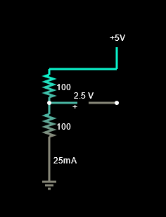

**General formula:**

**Set 1:**

**R1 = 100 Ω, R2 = 100 Ω,**

**Set 2:**

**R1 = 55 Ω, R2 = 100 Ω,**

**Set 3:**

**R1 = 44 Ω, R2 = 79 Ω,**